Practical Circuit Diagram:
MESH ANALYSIS
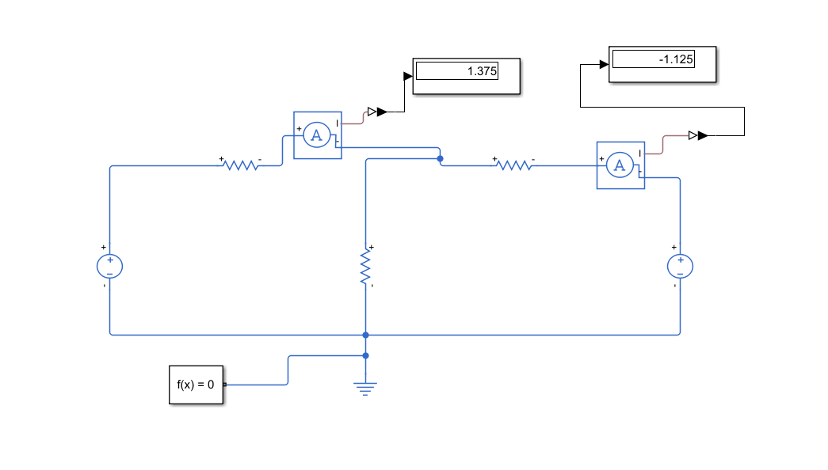
BRANCH CURRENT
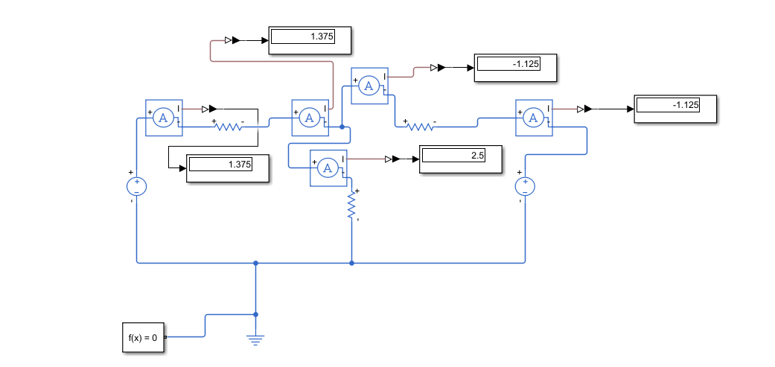
BRANCH VOLTAGE
